OLSEN SCHOOL ZONE FLASHING LIGHTS

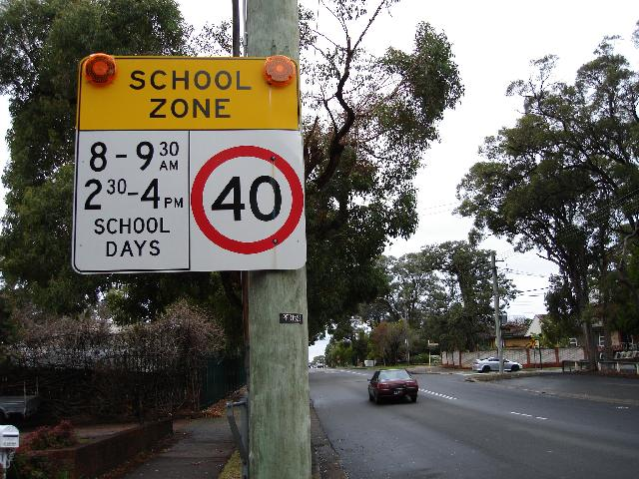

- Eight sets of Olsen lights have operated for the past two years with 100% reliability. RTA lights average 98.2%. (Morris Iemma media release 26/9/07 p.2 para. 11)
- No need for expensive back-to-base monitoring because of their reliability. RTA lights have back-to-base monitoring but regularly take up to a week to fix when they fail.
- Olsen lights reduce average speeds by 50% more than RTA lights. See: http://www.rta.nsw.gov.au/roadsafety/downloads/finalreport_flashinglights_2006.pdf p.vi para.1 and p.65 para.7. (Olsen lights are Type 1, RTA lights are Type 3).
- Olsen lights have GPS receivers in them to obtain current time from satellites giving them sub-second accuracy. RTA lights do not.
- Olsen lights are twice the diameter of RTA lights (200mm vs 100mm).
- Olsen lights are angled to face the traffic for maximum brightness. RTA lights point straight down the footpath and are often barely visible.
- Olsen lights cost $350 + installation per sign vs. $58,000 per sign for RTA lights.
- Could be installed at every school zone in NSW for the cost of the RTA’s current rollout to just 4% of school zones. (Allowing $2,300 per sign including installation).
- Mr Olsen has no commercial interest. Technology given to the RTA to use for free.
- Mr Olsen wants RTA to issue a new tender for lights, maximum price say $5,000 including installation. No back-to-base monitoring or other unnecessary bells and whistles. Lights to be installed at all school zones in NSW.

Peter Olsen
13/55 The Grand Pde
Brighton-le-Sands 2216
www.schoolzonelights.com.au
9599-1811
0414-538-404

